


855
Industrial Drive
Mondovi, WI 54755
(715)-926-4444 or (715)-832-6062

Fax (715) 926-5659

APPLICATION FOR EMLOYMENT
(
PRE-EMPLOYMENT QUESTIONNAIRE}
AN EQUAL OPPORTUNITY EMPLOYER)
(
Liberty Exteriors is an equal opportunity employer dedicated to a policy of non-discrimination in employment based on an
Individual's race, color, creed, religion, age, gender, national origin, ancestry, veteran status, marital status, sexual
orientation or the presence of any non-job-related medical condition or disability, or other characteristics protected by law.
In reading a
nd answering the following questions, please keep in mind that none of the questions are intended to imply any
limitations, illegal preferences, or discrimination based upon any non-job-related information. This application will be given
consideration, but it's receipt does not imply that the applicant will be interviewed or employed.
If you need an
accommodation to participate in the application process, please contact our office at 715-926-4444.
PLEA
SE P
RI NT
I
POSITION APPLIED FOR:
Date Available to Start Work:
PERSONALD ATA
Name:
LSSI
rust
Mluu18
Address:
Slree(A ddress
uty
Slate

Z,p
Home Phone:
Cell Phone:
I
E-mail:

(
)

(

)

G
ENERALI N
FORMATION
1.
Have you ever applied for a job with Liberty Exteriors in the past? If yes, please give the date
Yes
No
-
-
of application and the position for which you applied.
2.
Have you ever been employed by Liberty Exteriors in the past? If yes, please give dates of
Yes
No
-
employment and position held.
I
3.
If hired, will you be able to work during the normal days and hours required for the position(s)
Yes
No
-
for which you are applying? (See attached job description) If no, please explain:
4.
Do you have any commitments to another employer that might affect your availability for
Yes
-
No
employment with Liberty Exteriors? (for example,. On layoff) If yes, please explain:
5.
If hired, can you furnish proof that you
are
at least 18 years of age Ld that you are eligible to
work in the United States?
If no, please explain:
-
Yes
-
No
I
6.
Do you now, or will you in the future, require Liberty Exteriors to sponsor an employment visa
-
Yes
No
-
for your continued employment?
LI
B
ERTY
E
X
TERIOR
S

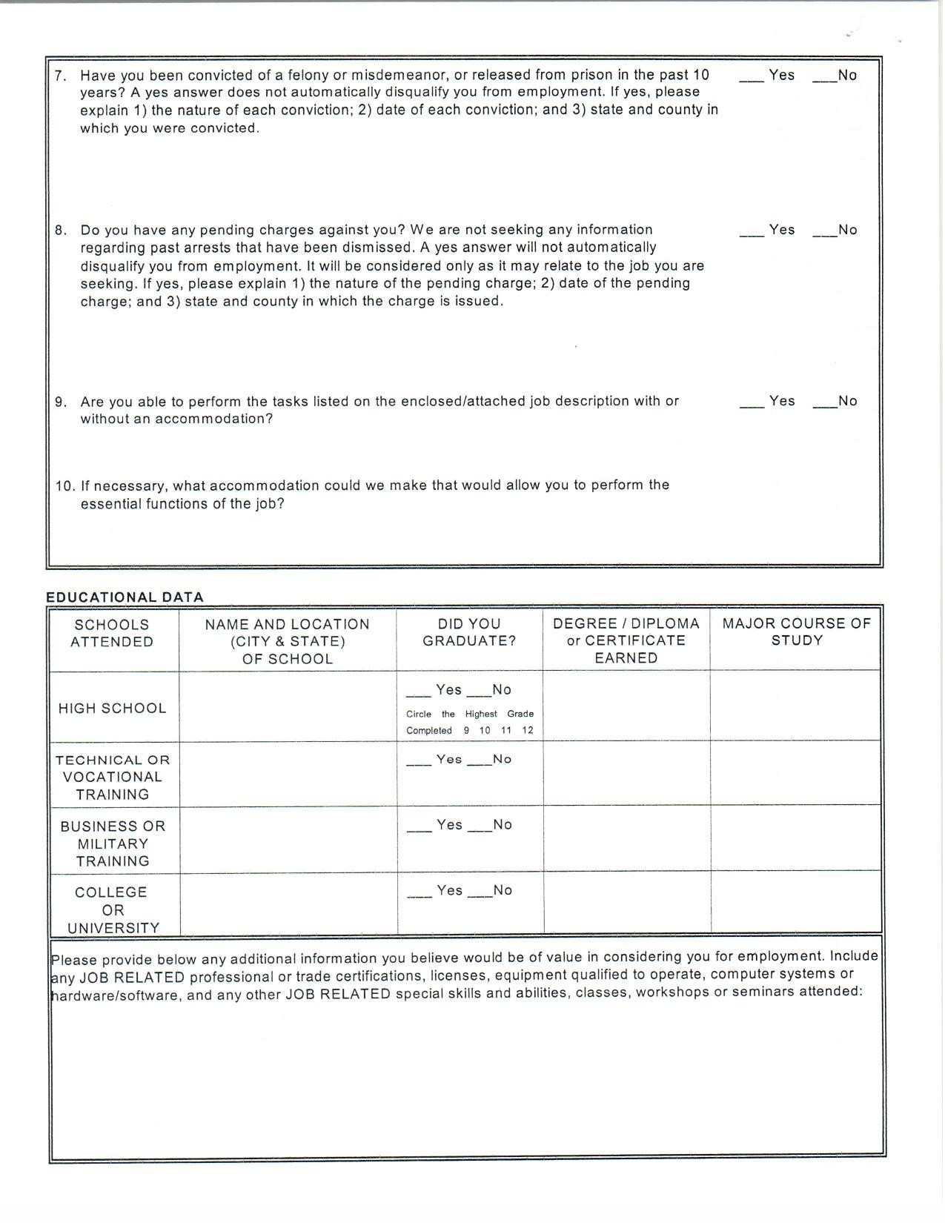

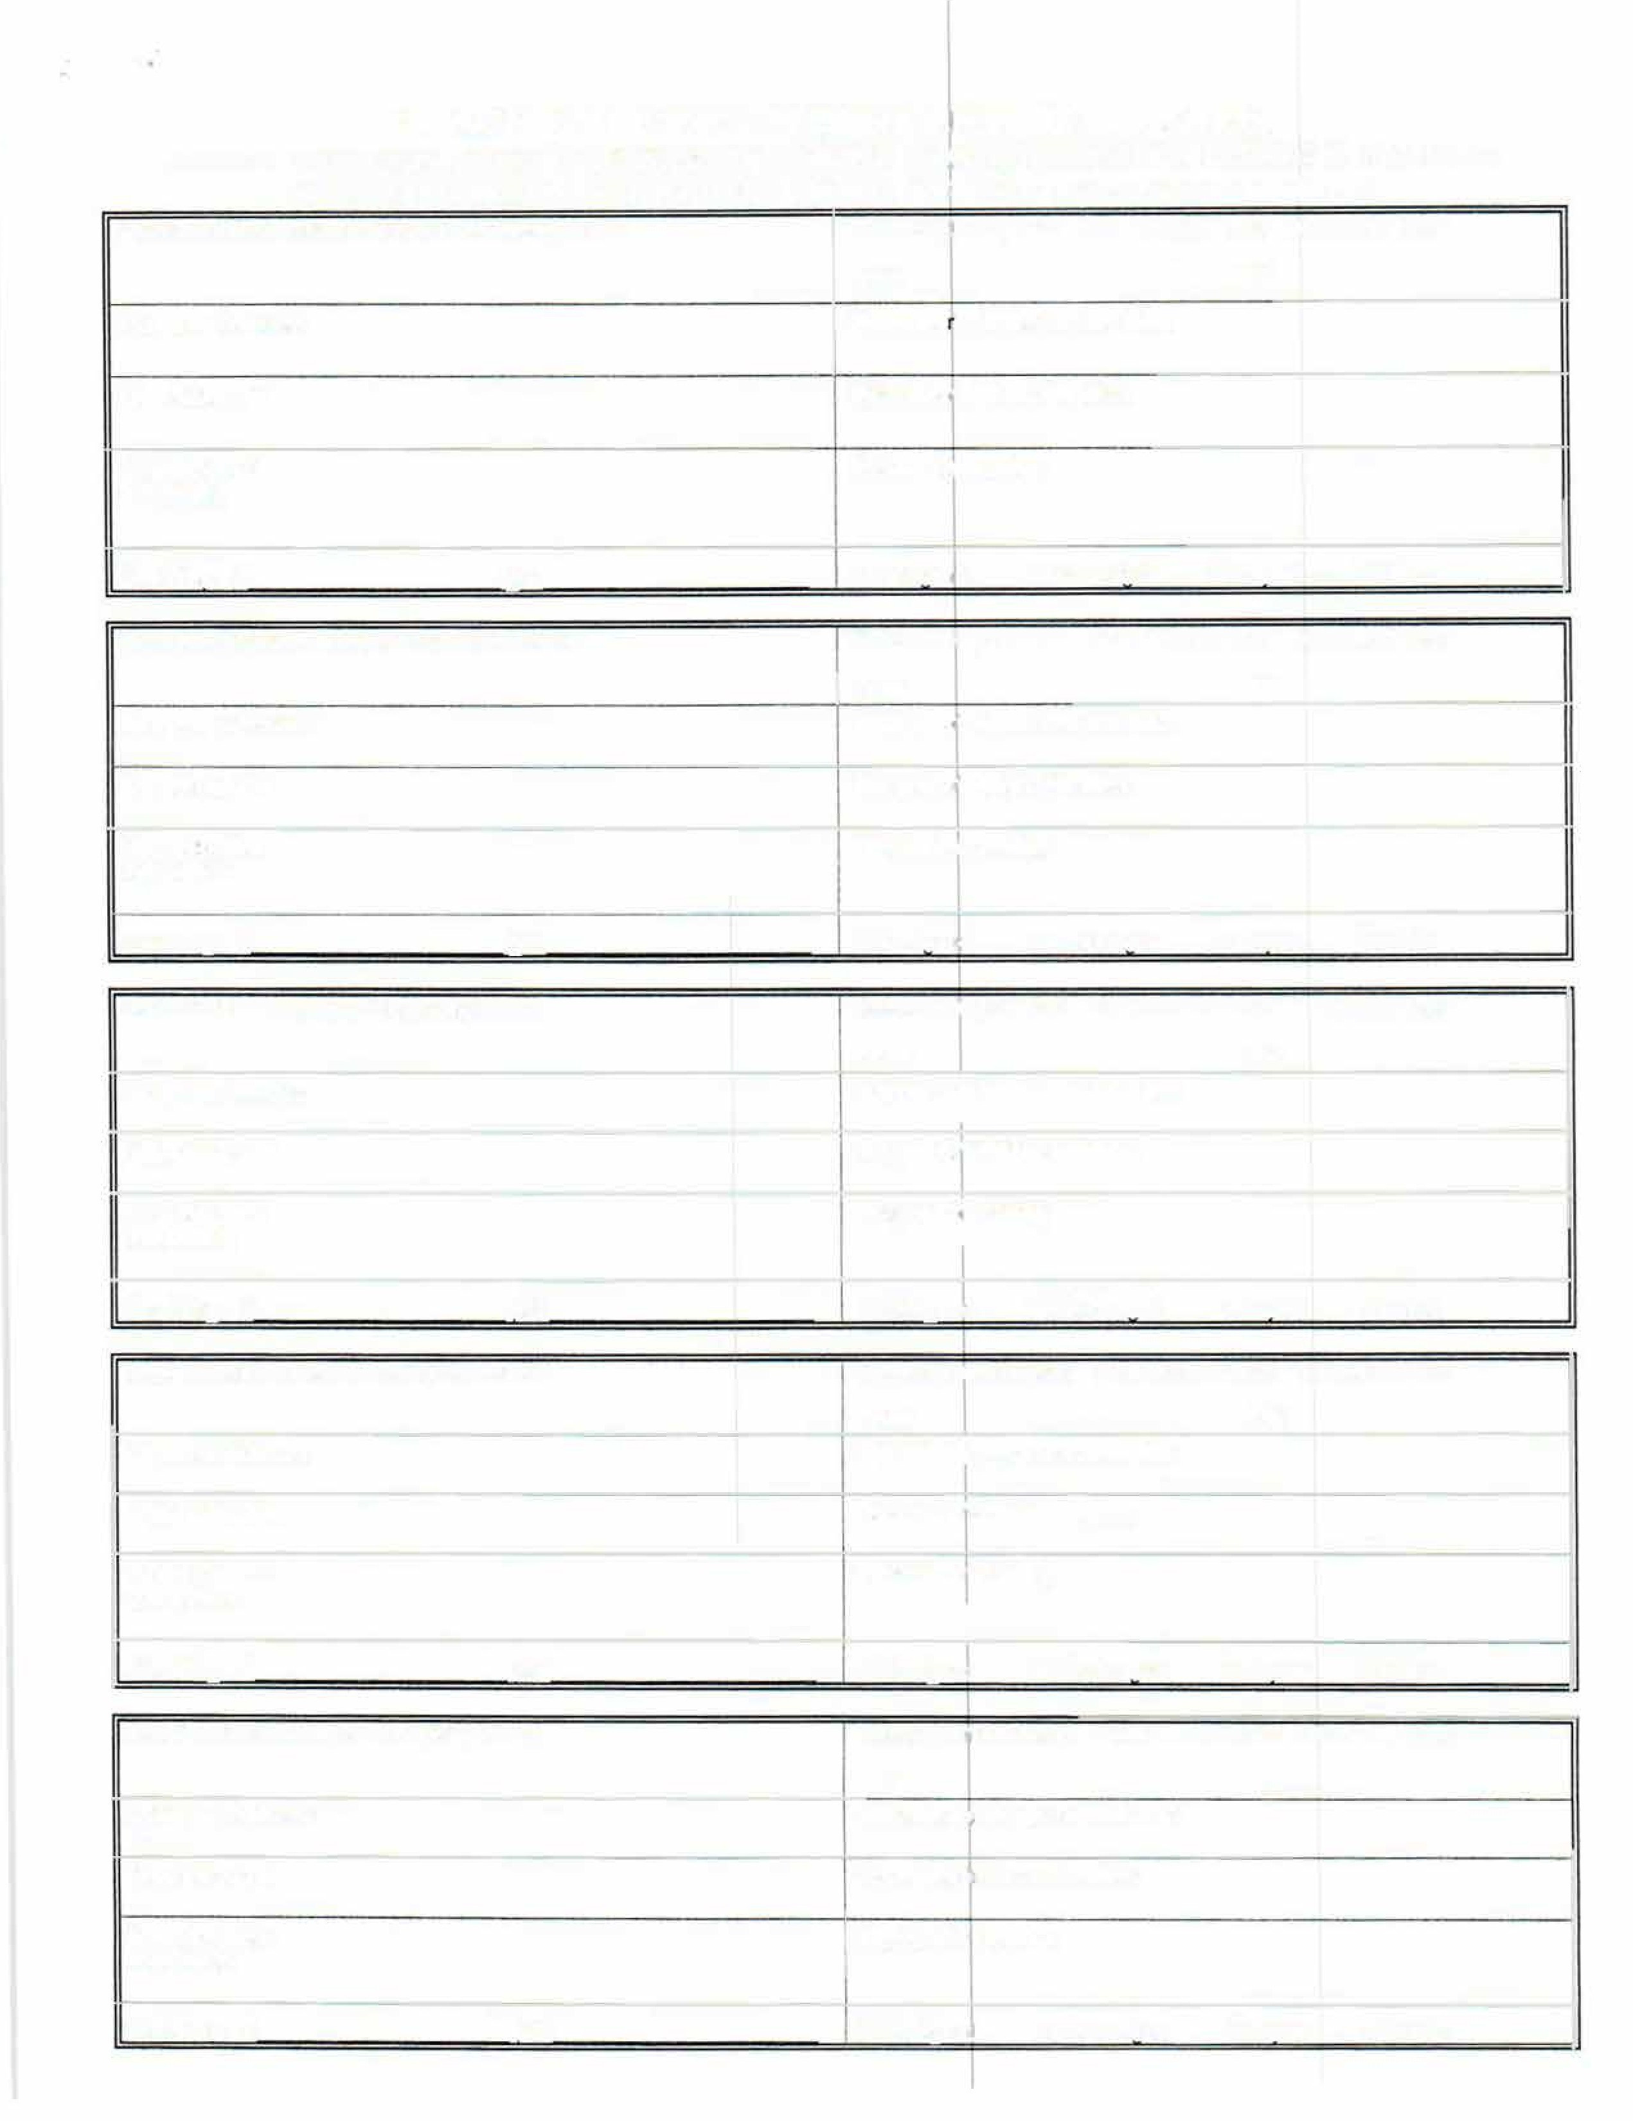
EMPLOYMENT HISTORY - PRESENT & FORMER EMPLOYERS
ATTACH ADDITIONAL SHEET IF NECESSARY• PLEASE COMPLETE EVEN IF A RESUME IS INCLUDED
PLEASE INCLUDE ALL EMPLOYMENT DURING THE PAST 10 YEARS AT A MINIMUM
Present or Most Recent Employer. Company Name:
Dates of Employment
From Month/ Year
To Month/ Year
From:
To:
Company Address:
Supervise 's Name and Job Title:
City, State, Zip:
Supervisor's Phone Number:
Your Job Title:
Reason for Leaving:
Job Duties:
Final Pav:
$
oer
D Reslaned
D Discharoed
D Lavoff
D Other
Next
Most Recent Employer • Company Name:
Dates of jployment
From Month/ Year
To Month/ Year
From:
To:
Company Address:
Supervisor's Name and Job Tille:
City, State, Zip:
Supervisor's Phone Number:
Your Job Title:
Reason for leaving:
Job Duties:
Final Pav:
$
oer
D Resianed
D Discharaed
D lavoff
D Other
Next Previous Employer • Company Name:
Dates of Employment
From Month/ Year
To Month/ Year
From:
To:
Company Address:
Supervlso
1
s Name and Job Title:
City, State, Zip:
Supervisor's Phone Number:
Your Job Title:
Reason fo
1

Leaving:
Job Duties:
Final Pav:
$
oer
o
Reslaned
D Discharaed
□
Lavoff
D Other
Next Previous Employer• Company Name:
Dates of Employment
From Month/ Year
To Month/ Year
From:
To:
Company Address:
Supervisos Name and Job Title:
City, State, Zip:
Supervisor's Phone Number:
Your Job Title:
Reason for Leaving:
Job Duties:
I
Final Pav:
$
per
o
Reslaned
D Discharaed
D Lavoff
□
Other
Next
Previous Employer • Company Name:
Dates of Erployment
From Month/ Year
To Month/ Year
From:
To:
Company Address:
Supervisor's Name and Job Title:
City, State, Zip:
Supervisor· Phone Number:
Your Job nue:
Reason for Leaving:
Job Duties:
Final Pav:
$
oer
D Reslaned
D Discharaed
D Lavoff
D Other

Please account for any time you were not employed after leaving school in the past ten years (You need not list any unemployment periods of one month or less).
Time Period(s) Reason(s) for Unemployment
If vou were unable to list all oast lobs or oeriods of unemolovment durina the oast 10 vears on this form olease use an additional sheet.
OTHER JOB-RELATED EXPERIENCE: Some people gain job-related experience in positions other than as an employee. For instance, an accountant may gain experience as a treasurer of a civic or school organization, or a manager may gain experience

while working on civic projects, or in school organizations or in PTA activities. Please list and describe any paid or unpaid activities, honors, experience, or training that might aid you in performing the job(s) for which you have applied, and have not been listed previously in this application. (You may omit any activities, honors, memberships or other items that tend to identify your race, sex, national origin, age, disability or other personal traits that you prefer not to disclose.)

IMPORTANT
Initials PLEASE READ CAREFULLY AND INITIAL EACH PARAGRAPH BEFORE SIGNING
I promise that the information provided in this employment application (and accompanying resume, if any) is true and complete. I understand that any false information, inaccurate information, or omissions may disqualify me from further consideration for employment,
and may be justification for my dismissal from employment by Liberty Exteriors. If discovered at a later date. I agree to immediately notify Liberty Exteriors if I should be convicted of or changed with any crime, other than a minor traffic offense, while my job application is pending, or during my period of employment, if hired.
I authorize any person, school, current employer (except as previously noted), past employer(s), government or investigative agencies, and other organizations that may be named in this application form (and accompanying resume, if any) to provide Liberty Exteriors with relevant Information and opinion that may be useful to it in making a hiring decision, and I release such persons and organizations from any liability and damage arising from the release of this information.
If offered a job that requires it, I give permission for a drug test and a job-related complete physical examination, and I consent to the release to Liberty Exteriors of any medical information they deem necessary in assessing my capability to perform the essential functions of the work for which I am applying (with or without a reasonable accommodation).
I understand that, if hired, I may not hold other employment, nor engage in consulting, sales, investments or other activities that may create a conflict of interest with Liberty Exteriors.
I understand that if employed and my employment is terminated by Liberty Exteriors for dishonesty, breach of trust. or any criminal acts, the authorities may be notified and I may be criminally prosecuted.
I understand that this application does not, by itself, create a contract of employment. I understand and agree that, If hired, my employment is for no definite period of time, and may be terminated at any time. I understand that only the President of Liberty Exteriors is authorized to change any of the terms of employment and that any changes must be specific and in writing.
Aoolicant's SiQnature: Date:
This form has been designed to strictly comply with Stat& and Federal fair EMPLOYMENT practice laws prohibiting employment dlscrimlnahon. This form has been revised to comply with the provisions of the American with disabilities Act and the final regulations and inlorprellve guidance promulgated by the EEOC on July 26, 1991.

General Requirements / Description
Candidates should be self-driven, results-oriented motivated self-starters, with a positive outlook, and a clear focus on high quality. To join our team, you must be a prompt, dependable and responsible individual; who takes pride in his work. All employees are expected to be clean and to be concerned with good personal hygiene, and are expected to dress appopriately.
Whenever and wherever people work together, certain stanards of reasonable conduct need to be established in order to maintain an orderly and efficient work atmosphere. You will be expected to make yourself aware of the importance of adhering to our operating policies and procedures.
The position is full time, and you will be expected to be able and available for work Monday through Friday for a minimum of 8 hours per day, weather permitting. Your job location will vary on a daily basis and you must have reliable dependable transportation.
Job safety is very important to you and the Company. We epect our employees to conduct themselves carefully at all times. All employees are expected to work in a safe manner and observe good safety procedures. All work areas are to be kept clean and free from debris. Tools and equipment are to be kept clean and in good repair.
The successful applicant for this position must be able to safely perform the following tasks continuously and repetitively throughout an 8-9 hour work day.
*** Read, understand, and execute a work write up
Communicate politely and effectively with co-workers and clients
Lift 851b consistently (and more at times depending on the product(s) being
installed/work being done), lifting overhead at least 50% of the time
*** Bend and lift repeatedly
Work comfortably and safely from a step ladder and an extension ladder
Carry heavy loads up and down ladders, safely and repeatedly throughout a day
** Work on uneven and slippery surfaces in a afe manner
Tolerate extreme weather conditions - both heat and cold - associated with an
outdoor job
* Follow all OSHA guidelines
I Acknowledge that I have read and understand the requirements as described above:
Applicant Signature: Date: _______


. .

